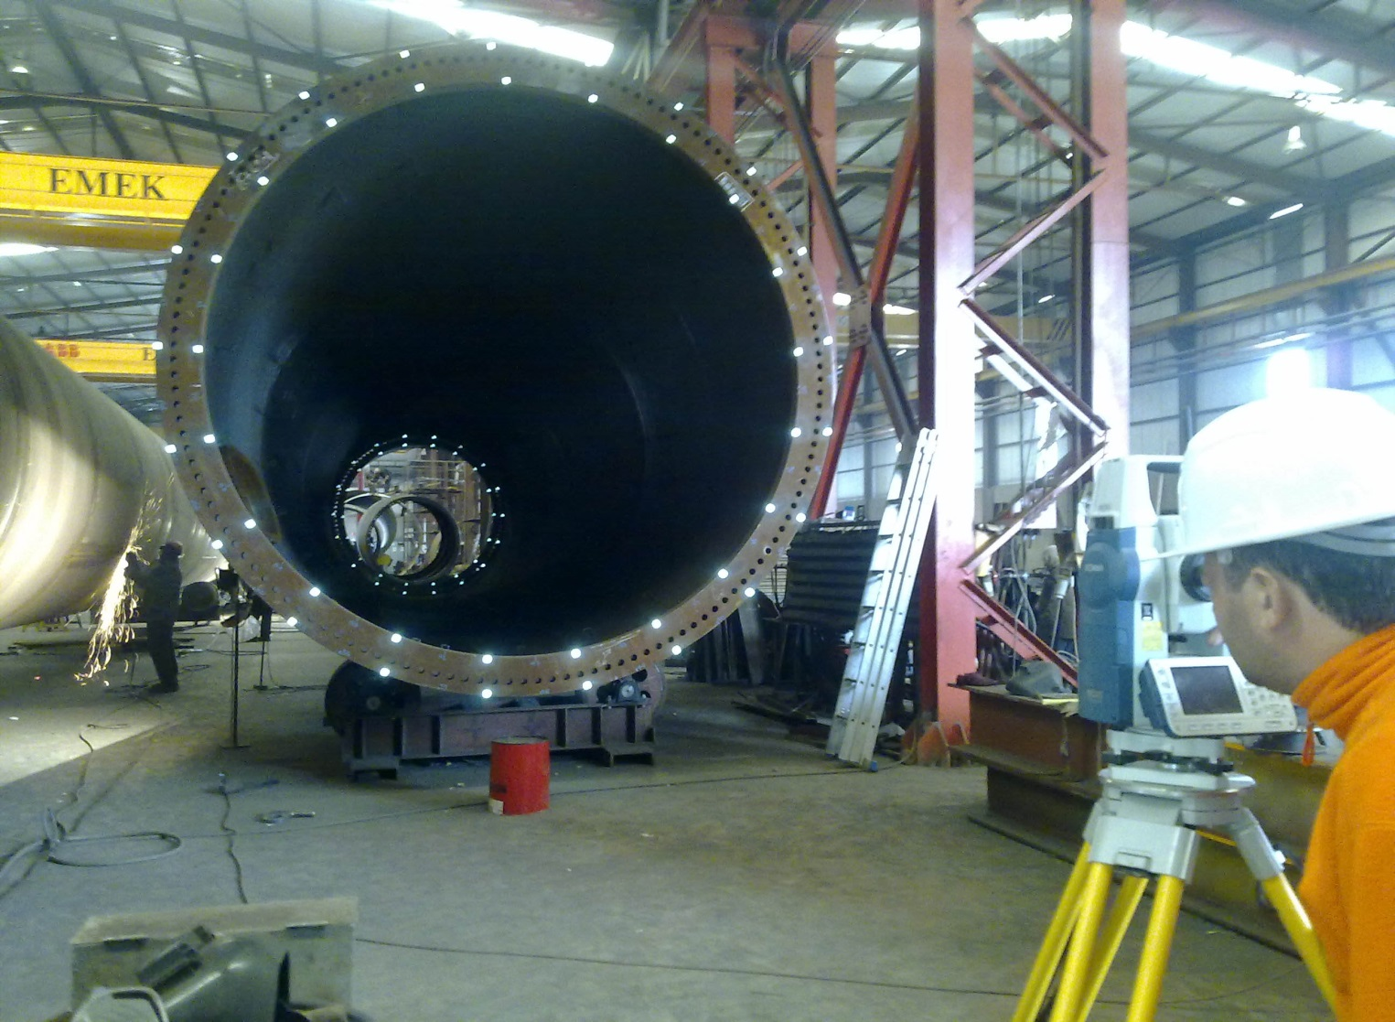

INDUSTRIAL SURVEYING

3

3

3

3

High Pressure Natural Gas and Regulating Station, Tema, Ghana

3

3

INDUSTRIAL SURVEYING

INDUSTRIAL SURVEYING

3

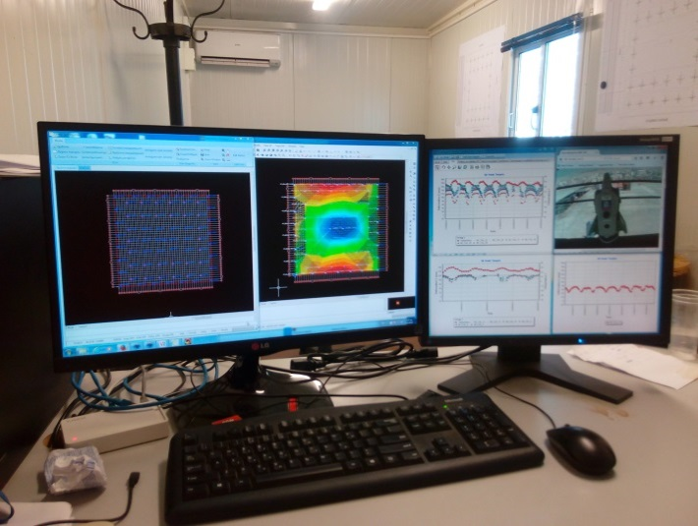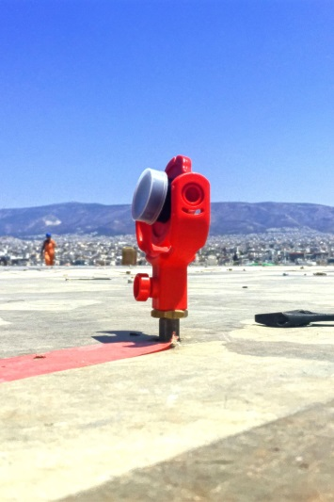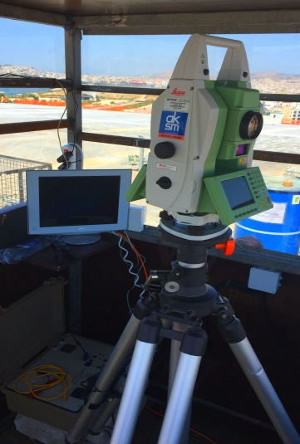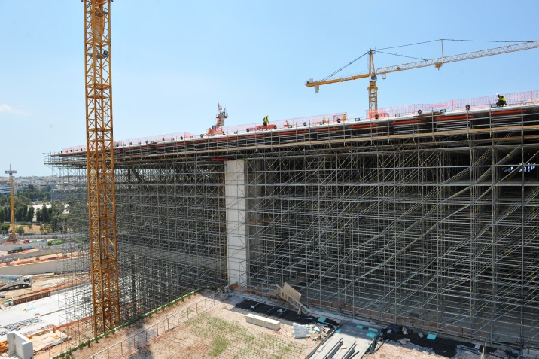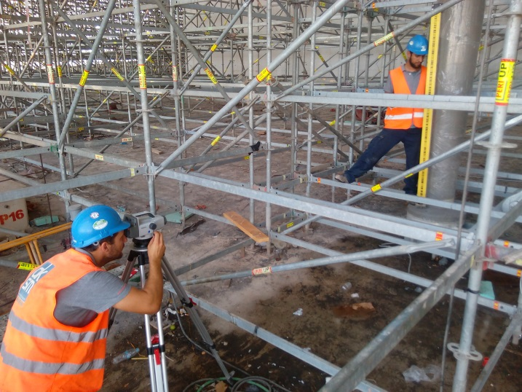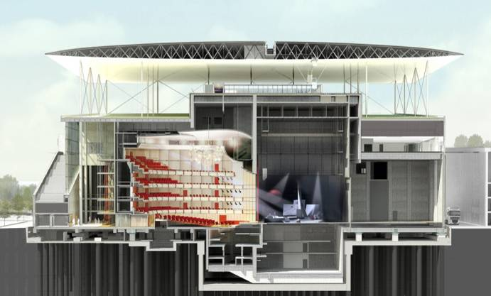

CASE STUDY: DEFORMATION MONITORING AT CANOPY OF STAVROS NIARCHOS FOUNDATION CULTURAL CENTER

www.aksm.gr

The ferrocement canopy of the Opera Building is made out of two 100m x 100m ferrocement skins : the superior one (top skin) and the inferion one (bottom skin) ; they are connected together by Ferrocement diaphragms and steel diagonal circular hollow tube sections.

The Canopy Roof is supported by 30 column through bolted connections to the column bases embedded in the concrete. On the top through bolted connection to the column heads provided with spring dampers and connected to the roof.

Since deproping did not took place executed by removing the props (the number of props doesn’t allow a controlled procedure) and took place by uplifting the canopy from the column heads, it has been required for a AMS to be installed in order to calculate the deformations on canopy’s surface as a result to the uplift sequence.

In order to calculate the deformation, on the canopy’s surface in relation to the uplift values the following schedule has been followed vertical :

* Uplift values were reordered through on LVDT indicator instolled on the column head.
* Deformation values on the column base were calculated on a daily basis through high accuracy levelling.
* Deformation on the Canopy’s surface were calculated through monitoring prisms installed on the casted surface (preinstalled couplers on skins) and a Robotic high accuracy station (Leica TS -30).
* Collected every 2 hours data were post processed through a SQL Based Database for monitoring data analysis. (Terramove).

Through the long term data collection and analysis hrough the deliverables consisting of

* adjusted values
* deformation diagrams (Dx, Dy, Dz)
* deformation contours,

the deformation behavior of the structure were analyzed on a 24h basis, monthly basis, 3 months basis, etc.

DEFORMATION MONITORING

7

5